**SMART SHEET EXTENSION**

This extension allows the user to connect their SmartSheet Account with Cliq.

Components :

* Smart Sheet Bot
* Smart Sheet Slash Commands
* Smart Sheet Widgets
* Smart Sheet Message Actions
* Smart Sheet Schedulers

**SMART SHEET BOT**

* In Smart Sheet Bot, you will find a welcome card and a few message actions.
* By clicking onLet's Explore you will get a Message card with the instructions of the Configure, Notifications & Create Task menu actions

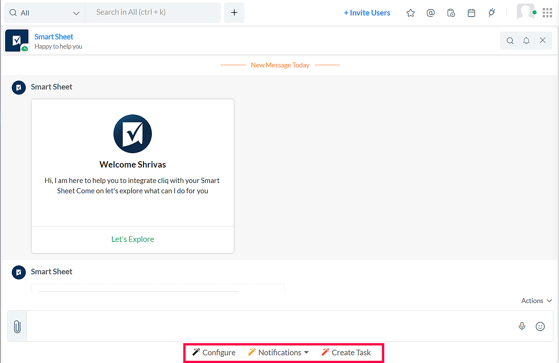

**ONBOARDING MESSAGE CARD FLOW**

Welcome "UserName"

Hi, I am here to help you to integrate cliq with your Smart Sheet Come on let's explore what can I do for you

**AFTER CLICKING LET'S EXPLORE**

**1. Configurations**   
  
 Clicking the Configurations Menu Action allows you to Configure the Smart Sheet to the Cliq's Widget.  
  
 **Additional Features** are enabled by selecting the notes and status equivalent columns in form   
 1. View notes and Add notes buttons in the widget sections  
 2. Mark as Complete button in the widget sections

**2. Notification**   
  
Clicking the Notifications Menu Action allows you to Map and UnMap the sheet to the Cliq  
**Map Sheet**  
Map a sheet to the particular channel and get notifications when there is a change in the sheet  
**UnMap Sheet**  
Edit - Change the mapped channel where the notifications to be posted.  
 Delete - Delete the mapping of the sheet.

**3. Create Task**   
  
After configuration is done you can add the task directly from the Bot to configured sheet.

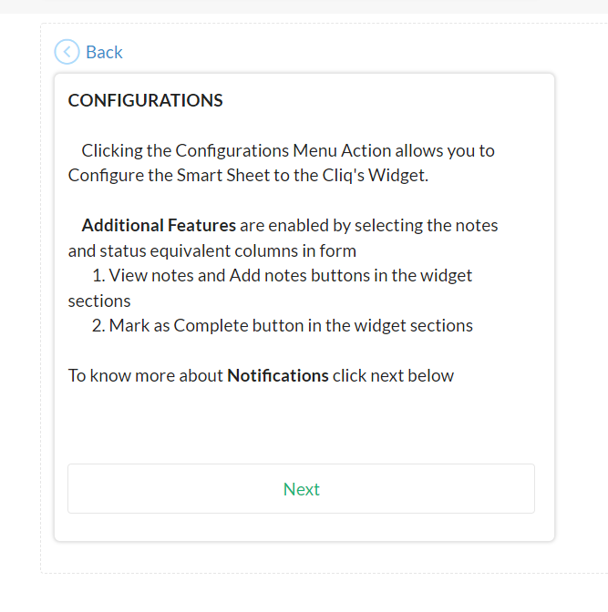

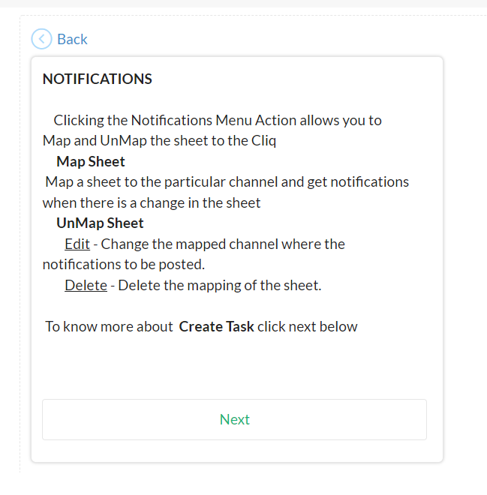

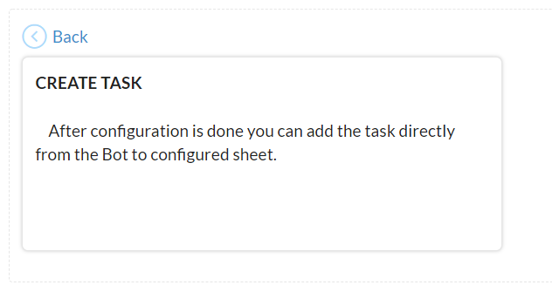

**Configure**

Configure Menu Action will allow the user to configure a specific sheet to the widget.

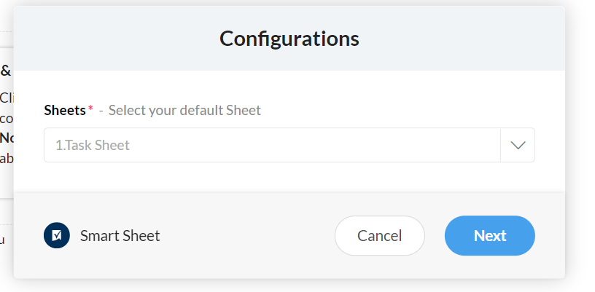

1. By Clicking **Configuration** menu action, a form opens to select the sheet that to be configured to the Cliq.

2. Then the user needs to select the equivalent Columns from their sheets to connect with the sheet to the widget.

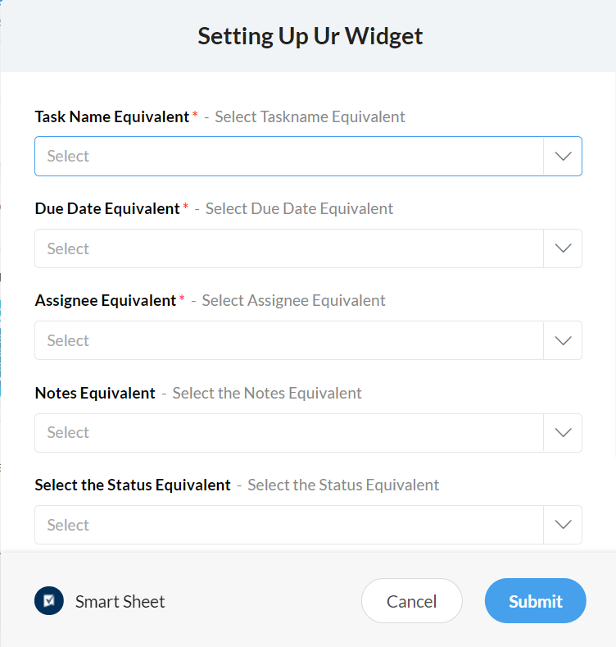 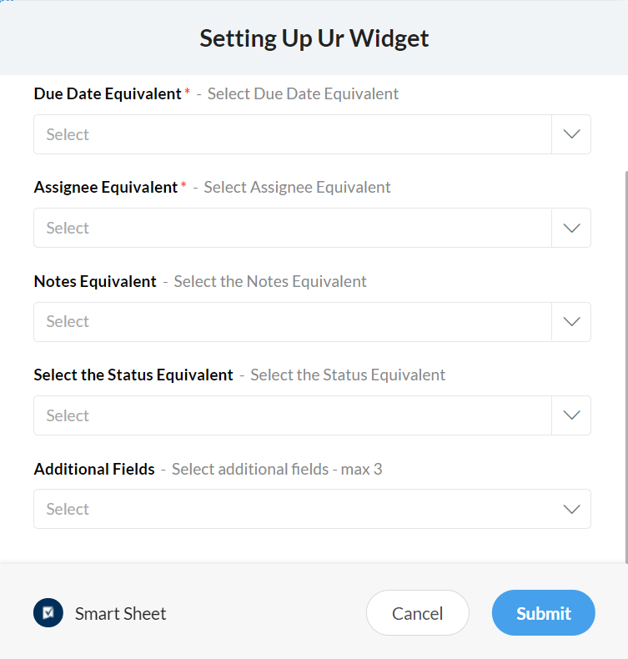

Fields in the Form:

* Task Name Equivalent *
* Due Date Equivalent *
* Assignee Equivalent *
* Notes Equivalent
* Status Equivalent
* Additional Fields

* refers to mandatory fields

**Additional features** are enabled by selecting the notes and status equivalent columns in the form such as view/add notes & mark as complete buttons in the widget sections.

For example:

If the notes equivalent column is not selected then in widget view notes and add notes buttons will not be displayed and add task form notes field will not be displayed

If the status equivalent column is not selected then in widget mark as completed button and in add task form the status field will not be displayed.

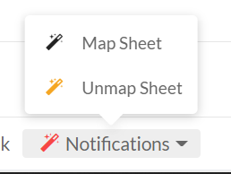

**Notifications**

Notifications Menu Action will allow the user to map multiple sheets with the channels to get notifications when there is a change.

1. Map Sheet 2. Unmap Sheet

**Map Sheet**

1.Select the Sheet and Channel to be mapped in the Form

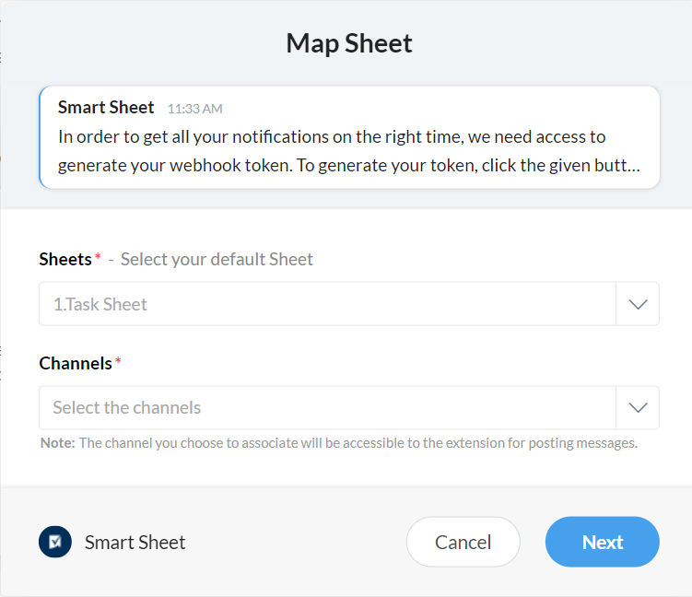

2. Select the Equivalent Columns for which notifications will be enabled

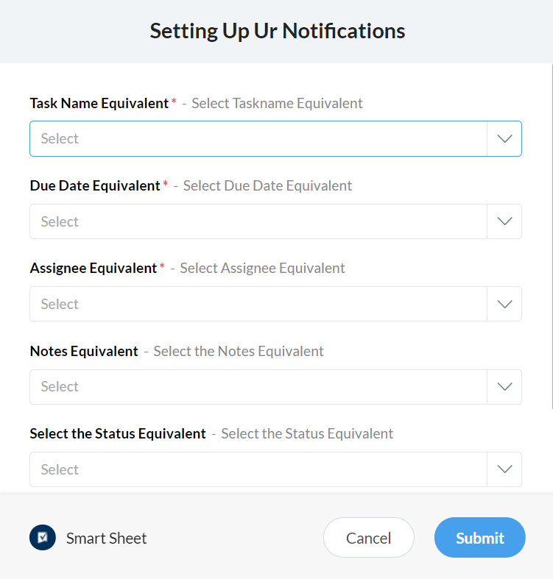

**Unmap Sheet**

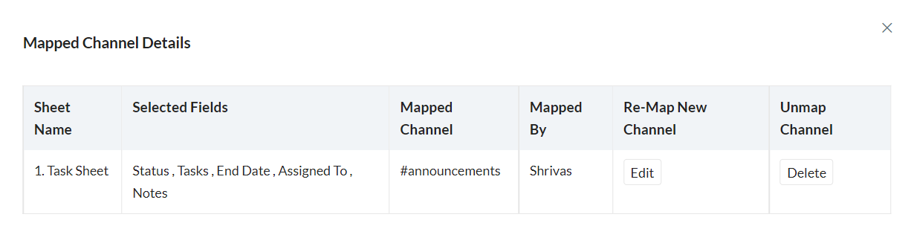

By clicking the menu action it displays the table which contains the details like Sheet name, Selected Fields, Mapped Channel, Mapped By, Edit and Delete.

* Edit Button allows user to Re-Map the sheet to the different channel alone
* Delete Button allows the user to delete the mapping of the sheet.

**Create Task**

By clicking the menu actions it displays the form to add task and the form fields changes based on selecting the equivalent columns in the configurations done in the configuration menu actions

For example:

If the notes equivalent column is not selected then in add task form notes field will not be displayed

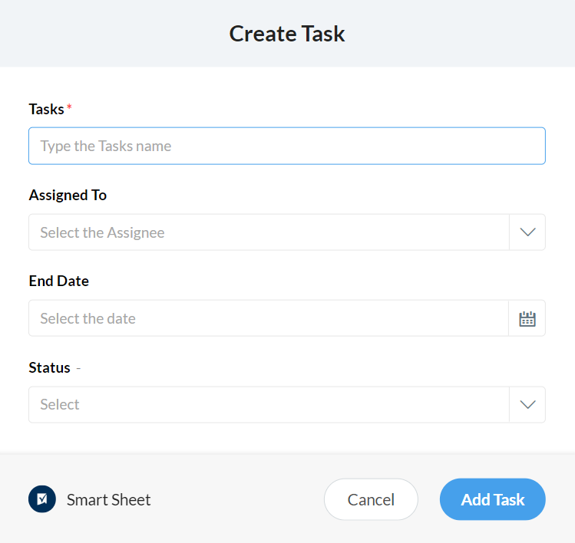

**SLASH COMMANDS**

**/smartsheet -** It gives a list of tasks assigned to the current user

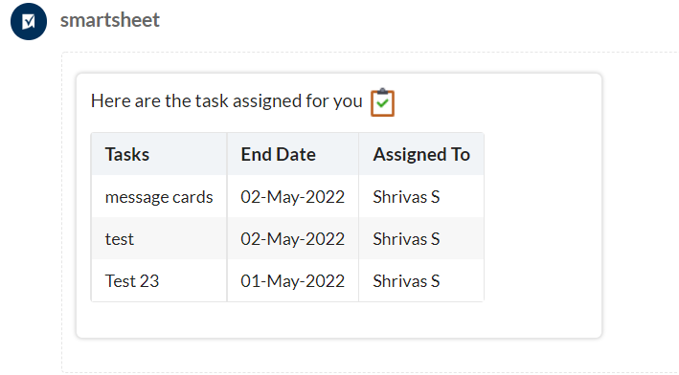

**/smartsheet @ Mention -** It gives the list of tasks assigned to that mentioned person

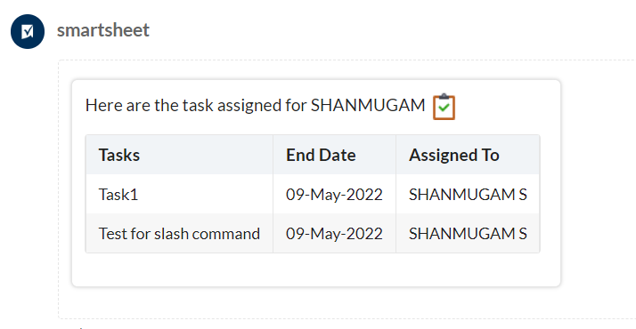

**Smart Sheet Widgets**

It has two tabs

1. My Task : It contains the task assigned to the user

2. Task : It contains all the task in the sheets.

**Reconfigure Button** : It allows the user to reconfigure the sheet directly from the Widget itself.(same form opens as in Bot configure menu actions)

**View Sheet Button** : It allows the user to view the sheet directly using the permalink.

**Add Task Button** : It allows the user to add a new task from the widget. (same form open as in Bot create task menu action)

There are four different possible ways that widget (section buttons) can show up based on the equivalent columns selected in the form during the configurations.

1.Not Selecting both the Status Equivalent and Notes Equivalent

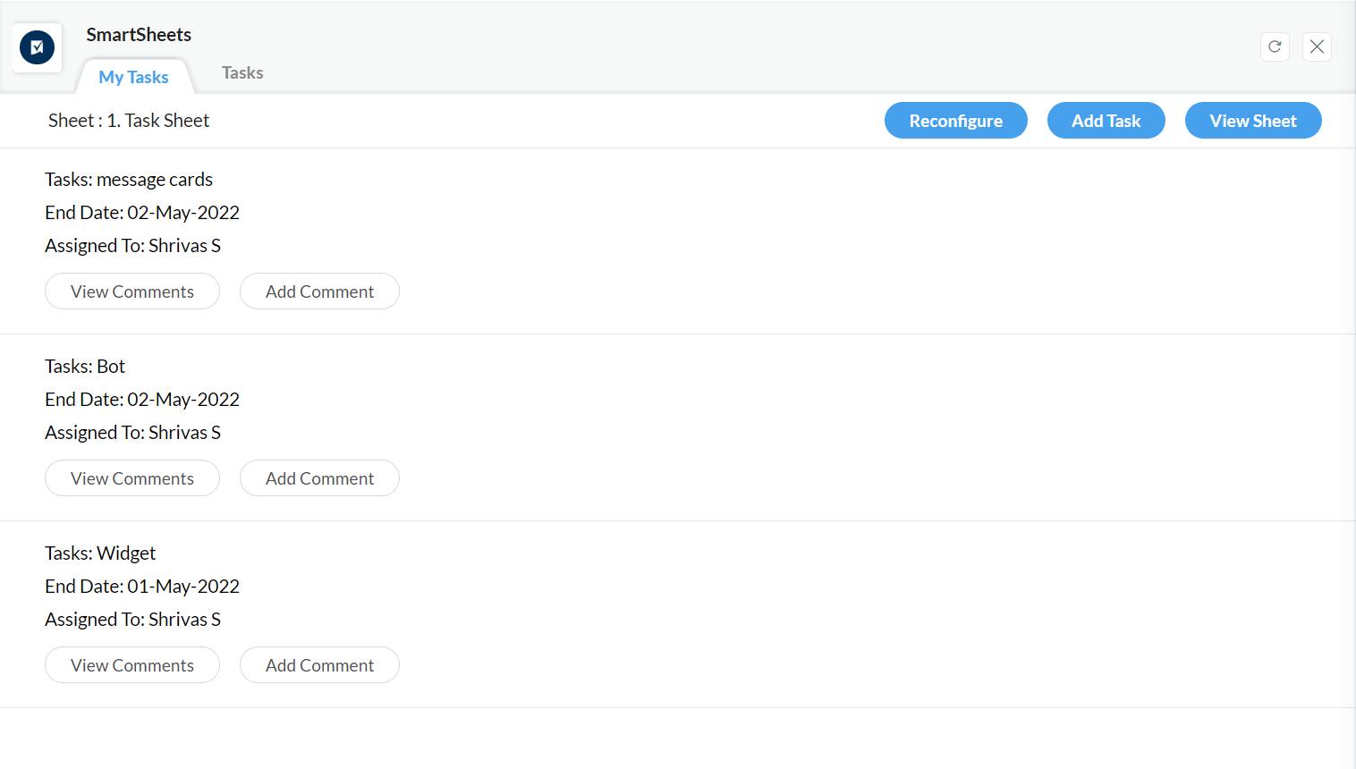

2.Selecting the Status Equivalent and not the Notes Equivalent

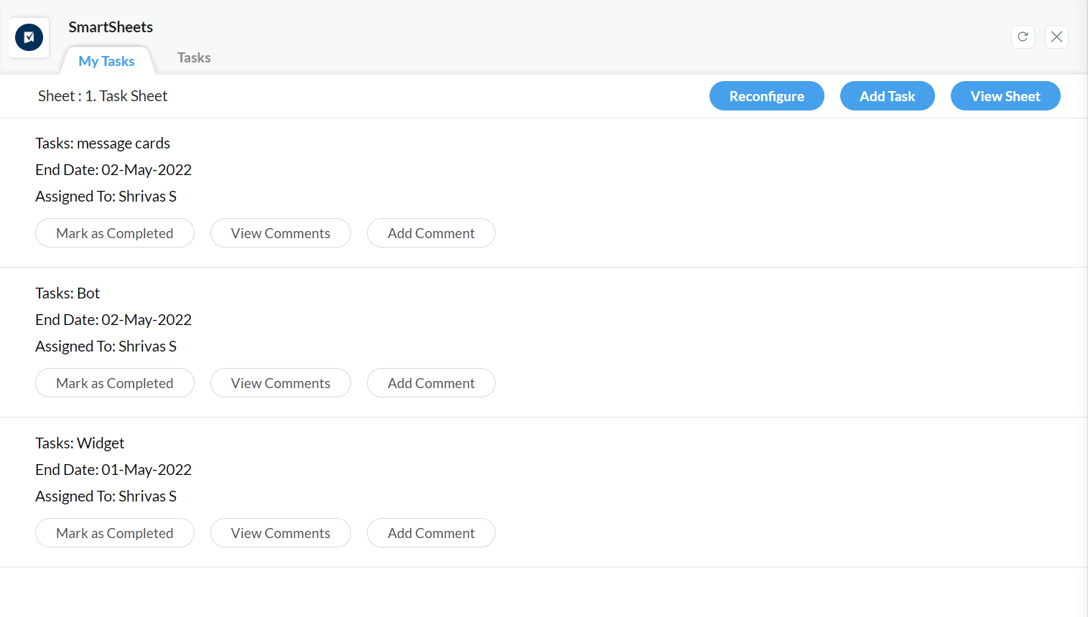

3.Selecting the Notes Equivalent and not the Status Equivalent

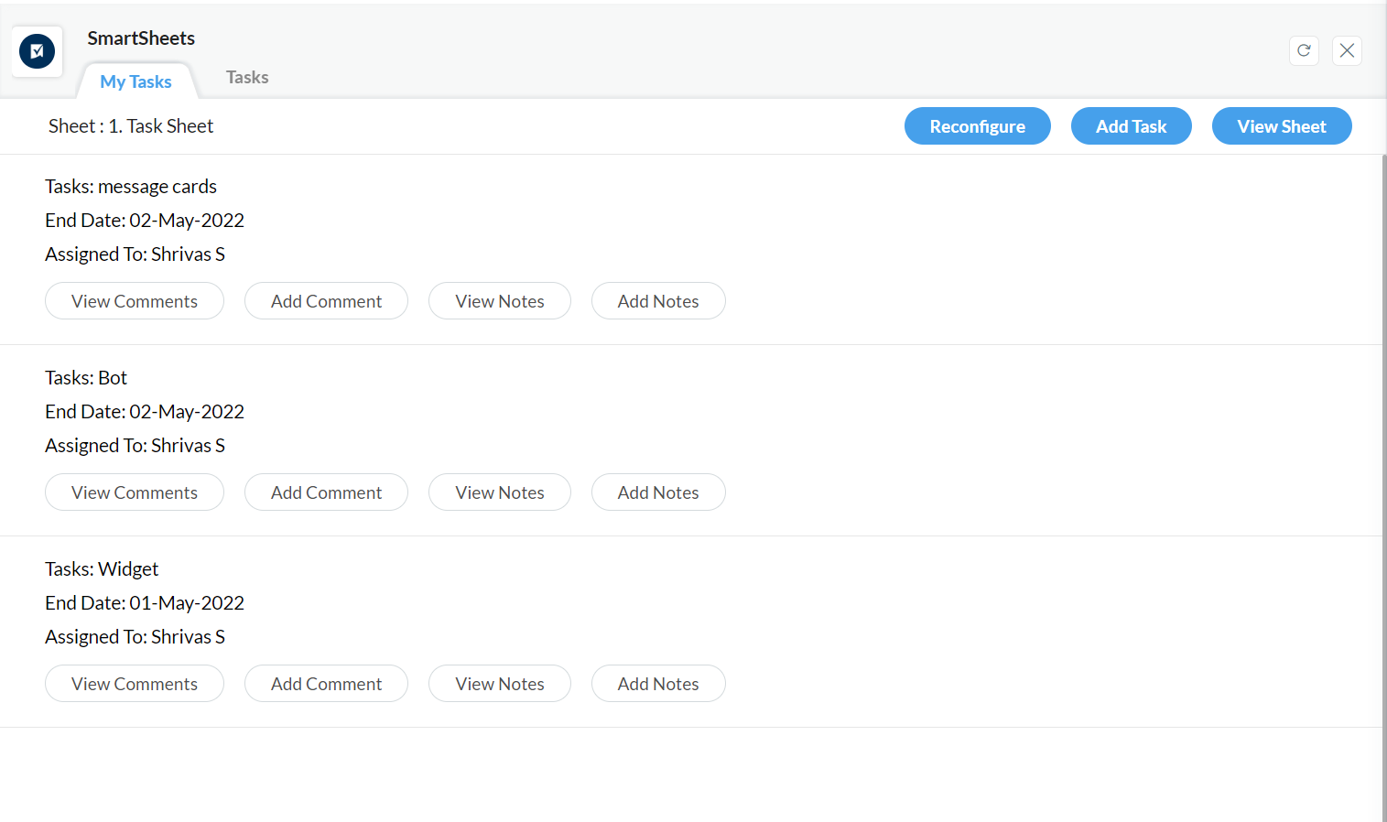

4.Selecting both the Notes Equivalent and the Status Equivalent

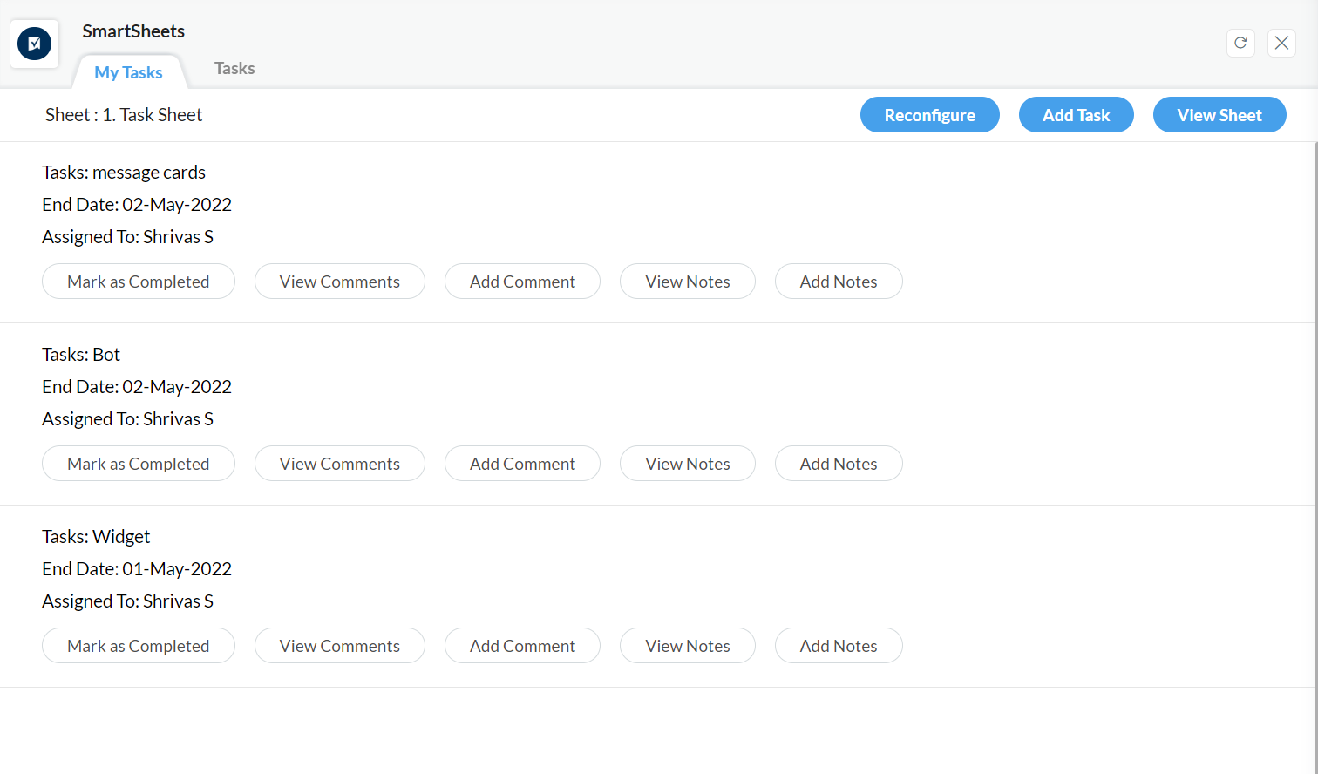

**Smart Sheet Message Actions**

1.Message Action will not work until Notes equivalent is given in the Configurations

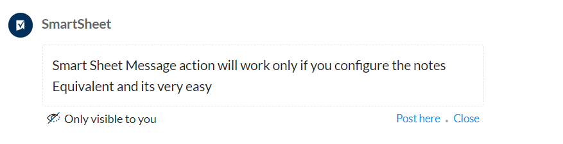

2. Message Action form to add notes to task after notes equivalent is given

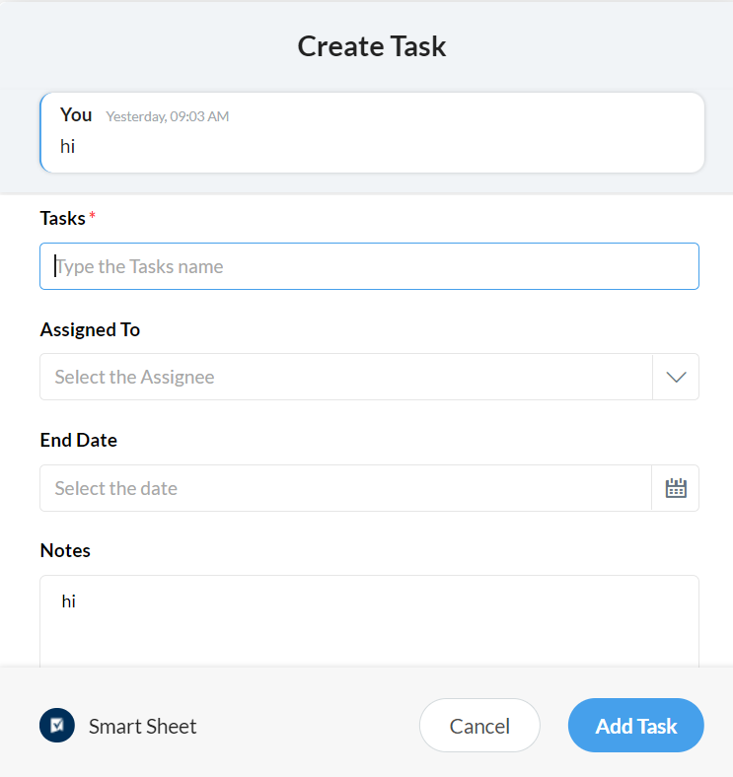

**Smart Sheet Scheduler**

Scheduler will work if the sheet is mapped to the channel and status equivalent is given during the configurations and sends the Fortnight Report (2-WeekReport)

1. Sends the personal Fortnight report to user's Bot

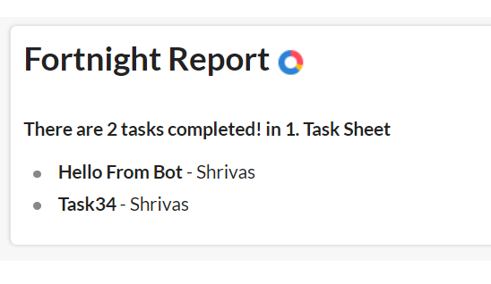

2. Sends the report of the completed task to mapped channel

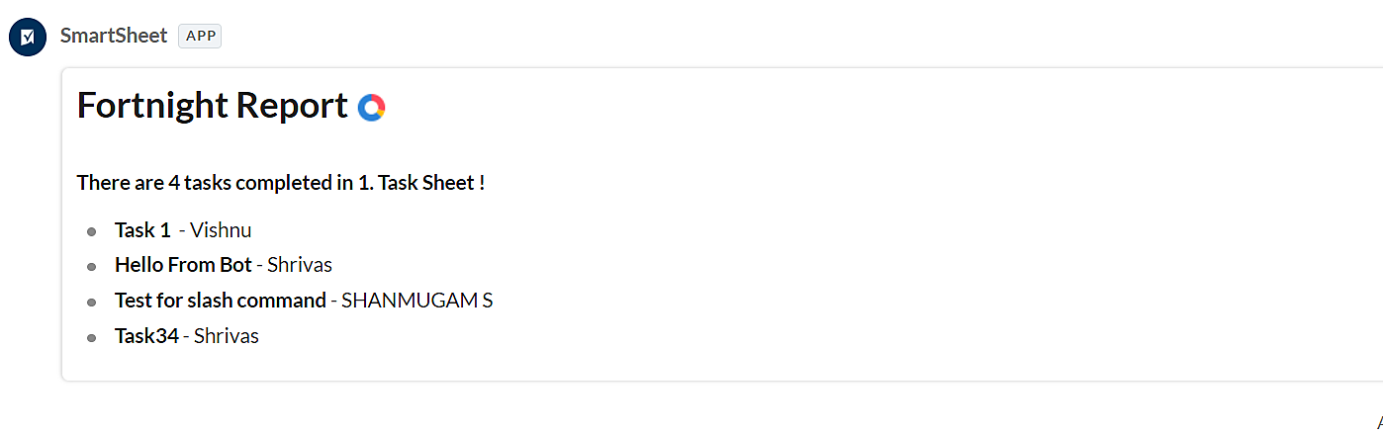

Extension Link to download : <https://cliq.zoho.com/installapp.do?id=4307>